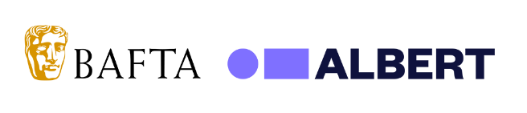
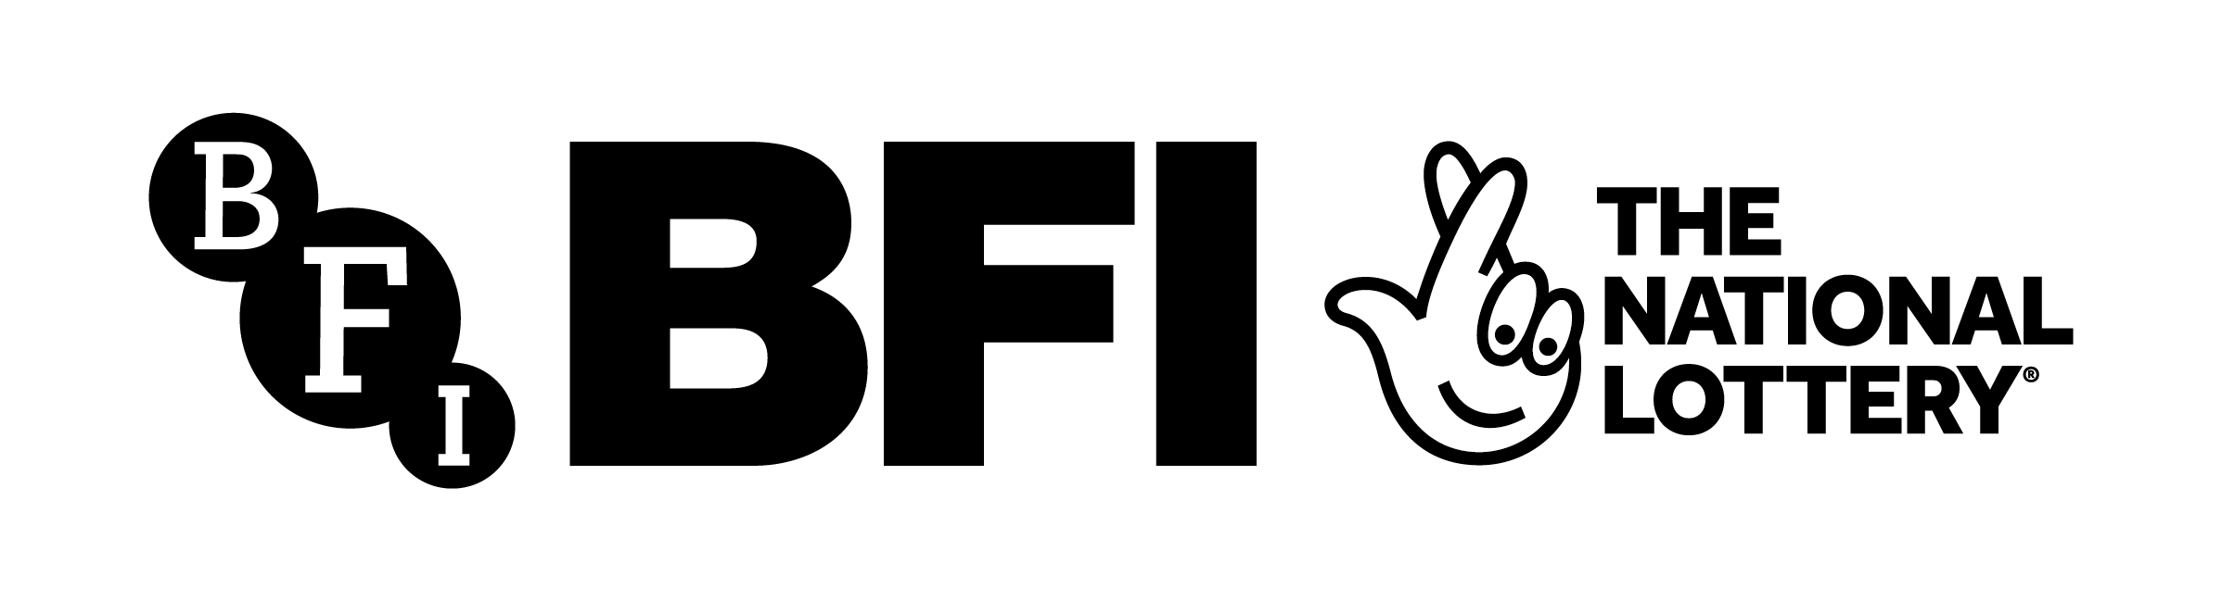

Embargoed until 8am Tuesday 21st November 2023

Piloting a path to net zero for the film and high-end television industries

The Screen New Deal Transformation Plan for Wales sets out plans for addressing energy use and waste

BAFTA albert today outlined the key recommendations from the Screen New Deal (SND) Transformation Plan for Wales, setting out a path to a sustainable future for the film and high-end television industries alongside its second annual Production Summit, held today in Cardiff.

This landmark report covers the changes to transport, energy use, waste and culture needed to meet net zero targets, distilling these actions into a clear timeline.

The series of key recommendations for production teams, commissioners, broadcasters and funding bodies was produced by Arup and BAFTA albert, supported by the BFI through its National Lottery Research and Statistics Fund.

Recommendations include:
- Shifting to renewable energy for productions on location by replacing diesel generators with battery power or hydrotreated vegetable oil (HVO) in the short term; upgrading studio spaces to use less energy and generate their own where possible through wind or solar power;
- A fundamental overhaul of transport options to eliminate fossil fuels, prioritising renewable energy sources such as electric cars and using virtual production methods wherever possible;
- Creating a circular approach to materials and assets used in production, establishing rental and reuse systems for set materials, costumes and kit; ensuring that food provided on set favours locally produced and low carbon options;
- Boosting the training and information available to production teams about the sustainability of existing production approaches; working with suppliers to the screen industry to reduce their waste and carbon footprints;
- Shifting culture within the industry to create a new sustainability standard for productions, establishing carbon budgets and harnessing the creative power of content makers and on screen talent.

Following on from the first SND report in 2020, produced by Arup, BAFTA albert and the BFI, Wales was chosen as a pilot area due to its fast-growing creative industry cluster and ambitious sustainability targets.

Working with screen organisations in Wales – Creative Wales, Ffilm Cymru Wales and Media Cymru – Arup undertook detailed analysis of available data, relevant policies and legislation, and combined this with interviews of film and high-end television industry stakeholders to devise their recommendations. The insights from the pilot project will be made available to other areas of the UK.

The report indicates who might oversee these recommendations, including studio managers, industry leaders, training providers and policymakers. albert will now work closely with stakeholders to roll out the Transformation Plan and monitor progress.

April Sotomayor, Head of Industry Sustainability, BAFTA albert said: “Climate change is impacting our world in immediate and sustained ways, and the film and high-end television industries have a key role to play in showing the ways to address it. This is a landmark route to a sustainable future in production, mapping out a practical approach to reducing both carbon footprints and waste. It is a very exciting step for the production community in Wales to pilot the Screen New Deal, and we’re committed to working with stakeholders on the ground to support programme-makers in adopting these recommendations. Now we all need to work together, and at pace, to encourage, implement and fund real progress which can be used as a blueprint for the rest of the UK.”

Harriet Finney, BFI Deputy CEO and Executive Director of Corporate & Industry Affairs, said: “In the race against time to address climate emergency, the Screen New Deal Transformation Plan for Wales sets out practical actions in areas of film and high-end television production that need to be taken in order to reduce our carbon footprint and meet net zero by 2050. In undertaking this ambitious project, alongside our partners in Arup, BAFTA albert and the participating organisations in Wales, we are proud to share these findings widely to benefit the industry across the UK. The BFI supports decisions to be taken at all levels of production to work more sustainably, benefitting the environment, society and the future of the industry.”

Florence Mansfield, Senior Climate Change Consultant at Arup, said: “Representing a huge milestone for the screen industry, the SND Transformation Plan for Wales report provides tangible and actionable sustainability guidance for all those involved in film and television production. Accelerating and enabling positive impact across the industry, the report outlines how ambitious change can be achieved through a holistic approach to carbon reduction, circularity and supporting all stakeholders in becoming more informed and empowered to make sustainable decisions. It was a huge privilege to continue our work with BAFTA albert, and we look forward to supporting the outlined actions as they come to fruition.”

Dawn Bowden, Deputy Minister for Arts, Sport and Tourism, said: “The screen industry in Wales is of huge value to our economy. In recent years we have seen numerous high-profile productions filming in Wales and making use of our world-class studio facilities and locations, bringing with them opportunities for our talented workforce as well as offering trainee placements. The benefits and potential of the industry are huge for Wales, but in line with our commitment to building a greener Wales we must be focused on ensuring we are all working together to minimise the impact on our environment, and identify ways that the screen industry can succeed with sustainability at the forefront.

“I was pleased that Wales was the chosen nation for this project. As part of the findings of this report and its subsequent recommendations, Welsh Government funding distributed via Creative Wales will be directly invested into sustainability initiatives, one of which is encouraging our studio facilities to participate in the BAFTA albert Sustainable Studio Standard this year. In doing so, the data-driven insights provided by the Standard will shed light on studios' progress in reducing their carbon footprint and they'll become part of an industry-wide movement shaping a greener future for film and television.”

Greg Mothersdale, Media Cymru Research & Development Producer and environmental sustainability lead, said: “We welcome the key findings of this comprehensive report which companies across Wales have contributed to as part of the Screen New Deal Transformational Plan pilot. We look forward to encouraging and curating innovative solutions from the media sector through Media Cymru activity in order to secure an environmentally sustainable future in this part of the world, and beyond.”

Recommendations from the SND Transformation Plan for Wales are already forming part of activity taking place in Wales. Before the call closed earlier this month, Greening the Screen was a fund from Media Cymru and Ffilm Cymru Wales, which will enable organisations to research and develop (R&D) sustainable products, services or processes that will green the screen industry in the Cardiff Capital Region. Organisations were able to apply for between £75,000 and £250,000 to deliver positive change across the sector with long-term solutions to the industry challenges of reaching net zero, and projects will begin in April 2024.

The second annual albert Production Summit is held today, 21 November at Techniquest in Cardiff. The event brings together industry leaders, production experts, industry suppliers and policymakers in Wales to consider the sustainability challenges facing the industry, and look at practical ways to overcome them in order to future-proof the screen industries and the planet. The full programme and details for accessing the stream from the event can be found here.

Ends.

Notes to editors

BAFTA albert
BAFTA albert is the leading screen industry organisation for environmental sustainability. Owned and operated by BAFTA, and founded in 2011, albert supports the film and TV industry to reduce the environmental impacts of production and to create content that supports a vision for a sustainable future. The industry-backed organisation offers online tools and training, events, practical guidance and thought leadership to all screen industry professionals to help them identify and act upon opportunities on and off screen which can lead to effective climate action.

Website | LinkedIn | Instagram | X | Facebook | YouTube

Arup
Dedicated to sustainable development, Arup is a collective of 20,000 designers, advisors and experts working across 140 countries. Founded to strive for humanity and excellence in everything that we do, we collaborate with our clients and partners, using imagination, technology and rigour to shape a better world.

Arup.com

BFI
The BFI
We are a cultural charity, a National Lottery distributor, and the UK’s lead organisation for film and the moving image. Our mission is:

• To support creativity and actively seek out the next generation of UK storytellers
• To grow and care for the BFI National Archive, the world’s largest film and television archive
• To offer the widest range of UK and international moving image culture through our programmes and festivals - delivered online and in venue
• To use our knowledge to educate and deepen public appreciation and understanding
• To work with Government and industry to ensure the continued growth of the UK’s screen industries

Founded in 1933, the BFI is a registered charity governed by Royal Charter.
The BFI Board of Governors is chaired by Tim Richards.

BFI website

BFI National Lottery Funding
Screen culture can shift hearts and minds on environmental sustainability. It can communicate the importance of reducing humanity’s impact on the planet, and show how we can do so. Storytelling can play a powerful role in uniting people from all backgrounds around this common cause.
We will take the ecological impact of activity into all our funding decisions, and work with partners to improve it over the next 10 years. We will seek to support approaches that result in overall benefit to the environment, rather than merely seeking to reduce harm.

We also recognise the urgency of the task at hand. Over the next 10 years, we will use our funding plans to scale requirements around environmental sustainability. We will also work with partners to develop effective support for awardees to engage with this strategic principle. This will draw on evolving best practice and will take into account the different baselines from which parts of the sector are working.

Creative Wales
A Welsh Government agency set up in 2020 to support the creative industries in Wales, with a remit to position Wales as the best place for creativity to thrive. An expert team connects people and businesses to foster new opportunities; providing knowledge and resources to upskill the workforce and support trainees; plus investing in ideas and people to help the creative economy flourish. Creative Wales provides information and support across the creative sectors – from music to animation including:
- Funding for film and TV production
- Access to home-grown talent and cutting-edge facilities
- Funding for training/skills provision
- Highlighting creative training opportunities throughout Wales
- International projects looking to partner or locate in Wales
- Wales Screen service - helping productions to source locations, studios, crew and facilities

Homepage | Creative Wales

Ffilm Cymru Wales
Ffilm Cymru Wales is the development agency for Welsh film. We are dedicated to advancing and sustaining a strong film industry for Wales; one that we can all be proud to call our own.​

We do this by providing funding and training to emerging and established Welsh filmmakers, offering exciting cinematic experiences to audiences across Wales, and developing new skills and career paths through a range of training programmes.

Media Cymru
Media Cymru is a collaboration aimed to turn Cardiff and the surrounding capital region’s media sector into a global hub for media innovation with a focus on green and fair economic growth. Led by Cardiff University, this strategic investment programme brings together 23 media production, broadcast, technology, university and local leadership partners for the first time to supercharge media innovation.

Consortium partners:
- Universities: Cardiff University, University of South Wales, Cardiff Metropolitan University (PDR)
- Development Agencies: Ffilm Cymru Wales
- Media and technology companies: Boom Cymru, Wales Interactive, Rondo Media, Unquiet Media, Nimble Productions, Rescape Innovation, Cardiff Productions, Gorilla TV, Seren Virtual Production , Dragon Post (Wales), Alacrity Foundation, Object Matrix, TownSq
- Local leadership: Welsh Government, Cardiff Council, Cardiff Capital Region
- Broadcasters: BBC Cymru Wales, Channel 4, S4C

Media Cymru is funded through £22m from UK Research and Innovation’s (UKRI) flagship Strength in Places Fund, £3m from Cardiff Capital Region, £1m from Welsh Government, through Creative Wales, and £23m match funding from industry and university partners.
media.cymru

